seen test cases by instLab 2: CS527

Release date: 7th August 2026
Submission date: 14th August 2026, 9AM.

Problem Statement:
Simulator a mini-computer system.

Users can write a program in a simple programming language, as specified in the language specification section. A compiler will compile the program, and will generate a byte code. Byte code will be read by a computer system, and will initialise a memory. The processor will read the instruction one by one to execute the program, and will modify the memory. At the end, memory will be written to the computer system in a file.

Finally, compilation and computer system should be invoked by a single main file, and executed as a single executable.

All the changes with respect to Lab 1 is done in blue
Assume all the registers in the architecture are of 32 bits. Memory is byte addressable,

Language specification:
Arithmetic operations
Language supports following basic math operations : + - / *
Dest Variable = <Operand 1 variable> <operation> <Operand 2 variable>
Dest Variable = <Operand 1 variable> <operation> <constant value>

Example:
x1 = x2 + 10
x1 = x2 - 20
The maximum value of constant could be 255.

Every addition/subtraction operation updates the following four global flags: Z N C V
Z is 1, if result of operation is 0
N is 1, if MSB of result of operation is 1
C is 1, {For addition: if the unsigned result is strictly less than either of the unsigned inputs}. For subtraction: if operand 1 is bigger than operand 2.
V is 1, {for addition: if both operands sign is same, and sign of result is different than operand’s sign.} {For subtraction: if the operands have different signs, and the result's sign matches the second operand's original sign}

Memory operations: Read and Write
Read <variable> <address>
Write <variable> <address> //address is a constant

Support of square brackets.
Dest Variable = [Operand 2 variable] //memory read.
[Dest Variable address] = Operand 2 variable //memory write to given address stored in a variable.

Operand could be a variable or a constant.
Example:
x1 = [x2]
[x2] = x1;
x1 = [0]

The maximum value of constant can be 255.

Read and Write should be considered legacy instruction. Should not be used in lab 2 onwards - though compiler should still be able to compile them.

Control operations: No control operation supported in today’s lab.

Language support labels. Rules:
- Labels have to start with . character
- They should be the first character of any line (no space or tab should prefix them).
- Label will alphanumeric string of characters. No spacial symbol, no :
- Line having label will have no other expression
Example:
.label1
.loop

Control operations:
B{Suffix} <label>

Suffix given in table below:

Example:
BEQ .loop
BGE .label1
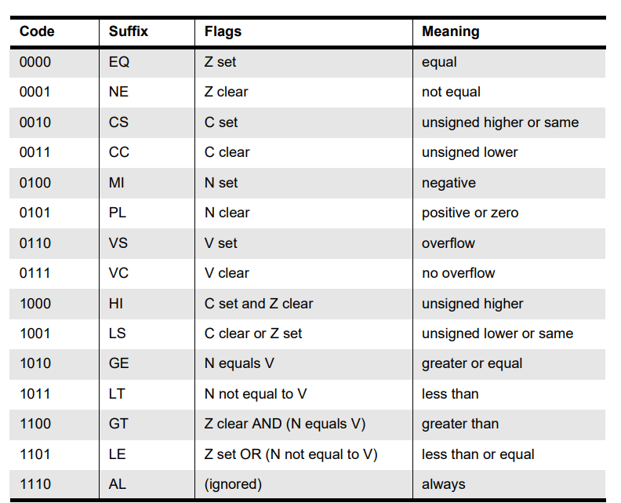
Table is taken from [REF1]
More information about these condition flags [ARM]

Data movement operation:
<Dest Variable> = <constant value>

Variable names: x0 to x255.
Constant value: 0 to 255

Support for comments. Any character following % will be ignored by parser.

Example: Sum of an array. Assume size of Array is stored at address 0, elements stored at 0x4 onwards location. Final result will be stored at address = size * 4 + 4.

x1 = 0 % index
x2 = 0 % sum
x3 = 0 % array address
x4 = [x3] % read the size of array
.loopback
x15 = x1 - x4 % compare
BEQ .exit
x3 = x3 + 4 % increase the address
x6 = [x3] % load the array data
x2 = x2 + x6 % update sum
x1 = x1 + 1 % increment index
BAL .loopback
.exit
[x3] = x2

Example bytecode output of the above program is (written in hex)
F 1 0 0
F 2 0 0
F 3 0 0
5 4 0 3
2 F 1 4
10 0 0 6
9 3 3 4
5 6 0 3
1 2 2 6
9 1 1 1
1E 0 0 FA
6 3 0 2

Byte code specification
Compiler generates a byte code for every operation and finally the byte code is stored in file called “program.byte”.
Format of each line of byte code
<opcode> <dest register> <operand 1> <operand 2>

For branch instructions:
<opcode> <0> <0> <relative offset of jump location>
Relative offset could be positive or negative, such that:
next instruction address = current instruction address + offset.

Operation | Opcode if second operand is a variable | Opcode if second operand is a constant
Add | 0x01 | 0x09
Subtract | 0x02 | 0x0A
Multiply | 0x03 | 0x0B
Divide | 0x04 | 0x0C
Memory read | 0x05 | 0x0C
Memory write | 0x06 | 0x0E
Data movement | 0x07 | 0x0F
Branch | 0x10 + code given in branch table

In case of memory read, write and data movement operations - operand 1 is 0.

Note that
- Every line has four bytes
- The maximum value for each byte is 255.

Processor specification

Processor
Instruction memory
Size 256 byte
Data memory
Size 256 byte

Processor has four functions:
reset()
fetch()
decode()
execute()

Following data elements are there in processor:
Int Register[256]
Int PC, opcode, dest, src1, src2
extern char Instruction[256], Data[4096];
Int end_of_simulation = 0

It has a global array of registers of size 256. And a global variable named PC. Also global flags N Z C V

Reset() initializes each element of register array to 0 as well initilize PC to 0
fetch(): reads four bytes from the PC address of instruction memory and stores in opcode, dest, src1, and src2 respectively
decode() : void and empty function at this time
execute(): based on opecode, it performs the operations. Once see 0 opcode, set end_of_simulation = 1

Memory
Memory is coded as a separate ‘c’ file.

Char Instruction[256];
Char Data[4096];

Assumes program.byte and data.byte present in the directory. The memory is byte addressable which means when you read instructions from char array will read the instruction bye-by-byte.

data.byte and program.byte are stored as an array of hex bytes. In each line four bytes in hex format (without prefix 0x) separated by space are stored

For example -1 is represented as
FF FF FF FF

initialize() {
//read the data from “program.byte” and populate Instruction memory
//read the data from “data.byte” and populate data memory.
}

finalize() {
//Write data.byte
}

Main file

main(int argc, char** argv) {

compile();
initialise();
reset();

while(end_of_simulation) {
fetch();
decode();
execute();
}

finalize();

}

It is suggested that the program file is passed as argument to your final executable - using argc and argv.

Directory structure

Following code files should be there:

main.c
compiler.c
compiler.h
processor.c
processor.h
memory.c
memory.h
Makefile

Some tutorials on multi-file compilation:
https://www.codewithc.in/tutorials/multi-file-programs
https://www.w3schools.com/c/c_organize_code.php
You can search more on the internet

Makefile tutorial:
https://makefiletutorial.com/

FAQs

Example user level programs:
- Sum of N numbers where N is fixed at program time
- Multiply two complex numbers
- Find the determinant of a 3x3 matrix.
Following can be done when branch instructions are introduced.
- Sum of N numbers where N is given at run time.
  - Four bytes starting from 0x0 stores N
  - Next 4N bytes store the N numbers.
- FIR filter response:
  - Input start at 0x0 of data memory. First four bytes tells size of array, say N. Next 4N byes are input array.
  - Output is stored at 0x10.
  - Weights are part of the program - as constants.

Data size
- In this assignment, data size is not specified. You can assume each operation is 8 bits, or 32 bits. 32 bit operation size is preferable. Data size is always 32 bit.
Submission Instructions:
- Submit as a single zipped file - containing all your code, and test programs.

